Report: HW2 Working with IMU data

Name: Wenqi Xu ID: 400156647

In the experiment , I set fc_hpf = 0.3, fc_lpf = 3, thres = 0.25, min_dis = 65, in this condition, I get the best result:

Precision = 0.8889 Recall = 0.8800 F1 = 0.8844

The following figure is visualization of the magnitude:

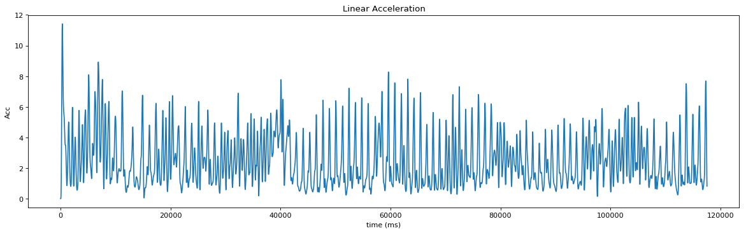

**Figure 1.** Visualization of the magnitude:

**The Effect of Cut-off frequency of Low Pass Filter**

I tune the parameters to be optimal and set it as thres=0.25, min_dist=65. To evaluate the effect of cut-off frequency of low pass filter, I set the cut off frequency of high pass filter to be 0.1 Hz, and change the frequency of low pass filter. The I get the results as Table 1.

**Table 1.** The Effect of Cut-off frequency of Low Pass Filter

|  |  |  |  |
| --- | --- | --- | --- |
| Cut-off Frequency | Precision | Recall | F1 |
| 2 | 0.2784 | 0.2700 | 0.2741 |
| 3 | 0.8776 | 0.8600 | 0.8687 |
| 4 | 0.8469 | 0.8300 | 0.8340 |
| 5 | 0.8238 | 0.8400 | 0.8317 |

From Table 1 I can conclude that the best cut off frequency of low pass filter is 3 Hz. If the cut-off frequency is around 2 Hz, the results is bad, because the signal of gravity cannot be completely filtered and have a pretty big effect on results. If the cut-off frequency is bigger than 3 Hz, the gravity signal can be filtered, but other useful signal can also be filtered, so the accuracy of results slightly decreased.

**The Effect of Cut-off frequency of High Pass Filter**

To evaluate the effect of cut-off frequency of high pass filter, I set the cut off frequency of low pass filter to be 3 Hz, and change the frequency of high pass filter. Then I get the results as Table 2.

**Table 2. The Effect of Cut-off frequency of high Pass Filter**

|  |  |  |  |
| --- | --- | --- | --- |
| Cut-off Frequency | Precision | Recall | F1 |
| 0.2 | 0.8878 | 0.8700 | 0.8788 |
| 0.3 | 0.8889 | 0.8800 | 0.8844 |
| 0.4 | 0.8889 | 0.8800 | 0.8844 |
| 0.5 | 0.8788 | 0.8700 | 0.8744 |

From Table 2 we can conclude that the best cut off frequency of high pass filter is 0.3 Hz. The frequency only have little influence on the step counting results.

**The way to Automatically Tune Cut-off Frequency**

First, we can set different value of cut-off frequency in array. Then use different parameter in array to execute program in loop, store the results in dictionary. Sort the results and get the optimal results. Find the parameters corresponding to the optimal result.

**Parameter Settings in the Peakutils.indexes**

After tune the parameter, I found that the best of thres is around 0.25 and min_dis is around 65.

Increase the value of thres, the steps detected by algorithm will decrease. Minimize the value of min_dis, more steps will be detected.